**Assignment - Module 1-4**

Name: Omkar Muley

Date: 08/07/2025

Course: Ethical Hacking

Module: 1–4 – Basic Linux Setup and Commands

# 1. Installing VirtualBox and Setting up Kali Linux

Task: Install VirtualBox set up a virtual machine with Kali Linux.

Action Taken:  
- Installed VirtualBox.  
- Downloaded the official Kali Linux ISO.  
- Created a new VM and installed Kali Linux successfully.

Screenshot:

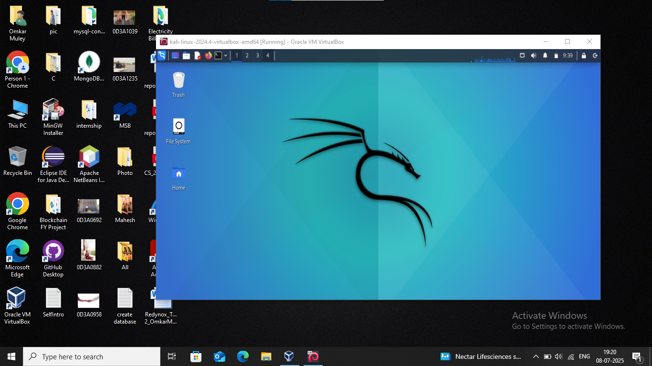

Fig 1: Screenshot of VirtualBox showing Kali Linux running

# 2. Kali Linux Installation and Update

Task: Install Kali Linux and run system updates.

Action Taken:  
- Kali Linux was installed using the official ISO file.  
- Ran the following commands to update:  
  
sudo apt update

Screenshot:

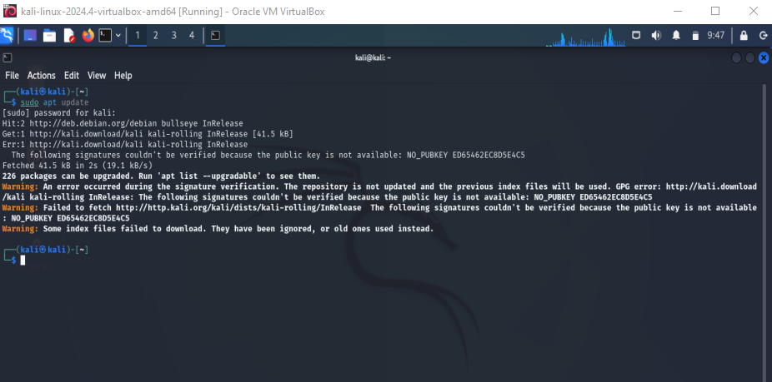

Fig 2: Screenshot of terminal showing update completion

# 3. Exploring Kali Linux Applications Menu

Task: List 5 tools and their purpose from the Applications menu.

|  |  |
| --- | --- |
| Tool Name | Purpose |
| Nmap | Network scanning and port discovery |
| Wireshark | Network protocol analysis and traffic monitoring |
| Metasploit Framework | Exploitation tool for vulnerability testing |
| Burp Suite | Web application security testing |
| John the Ripper | Password cracking tool |

Screenshot:

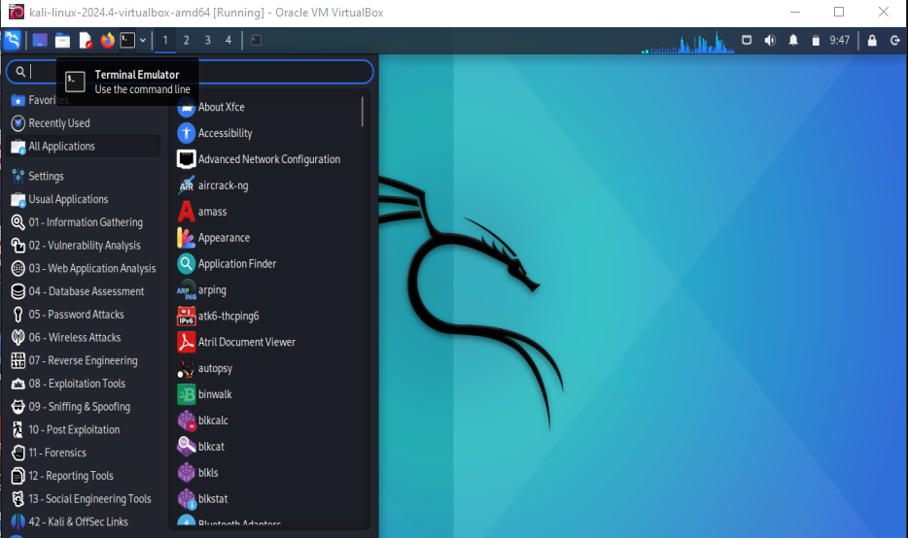

Fig 3: Screenshot of the Kali Linux Applications menu

# 4. Linux Commands Execution

Task: Execute basic Linux commands and capture terminal output.

* a. `find` command:

find /home/kali/Pictures

Screenshot: Terminal output

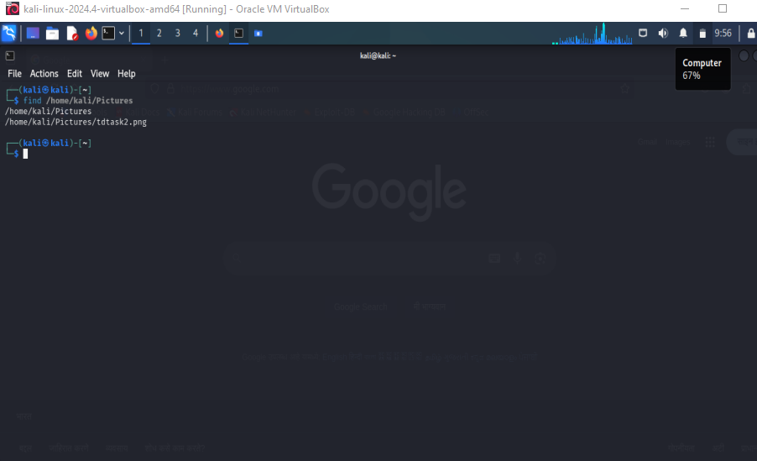

* b. `ping` command

ping -c 4 google.com

Screenshot Submission:Terminal output

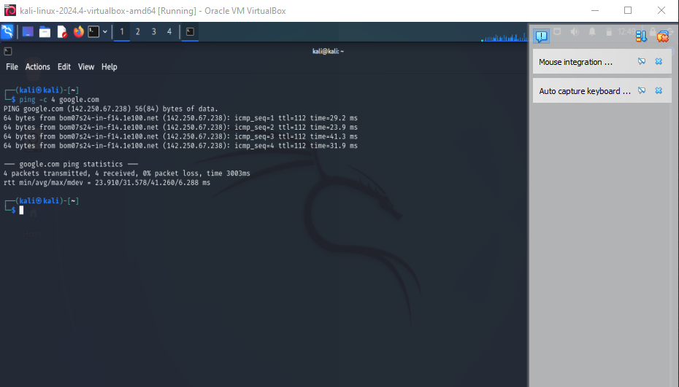

* c. `traceroute` command

traceroute google.com

Screenshot Submission:Terminal output

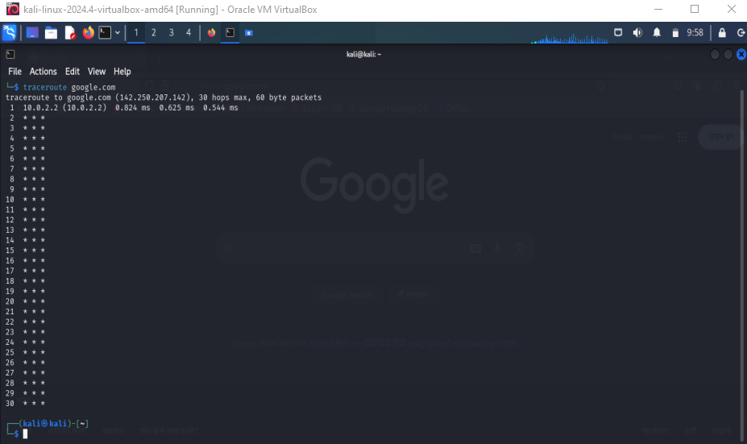

* d. `whoami` command

whoami

Screenshot Submission:Terminal output

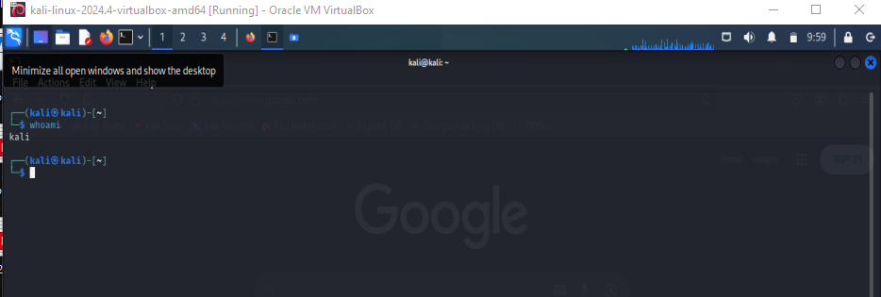

* e. `ps` command

ps aux

Screenshot Submission:Terminal output

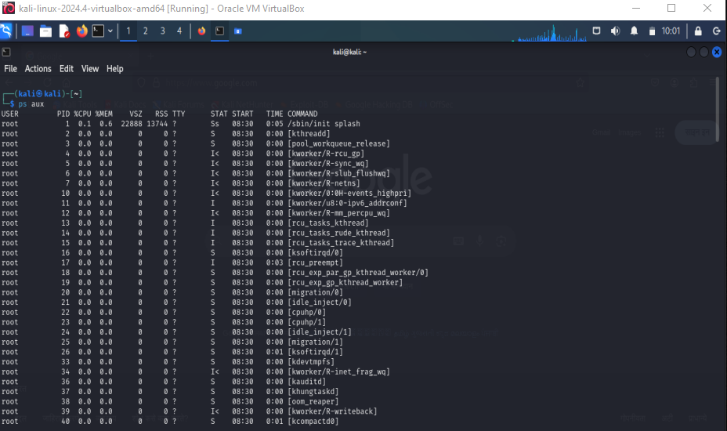

# Conclusion

Successfully completed all tasks for Module 1–4:  
- Installed Virtual Machine with Kali Linux .  
- Performed system update.  
- Explored commonly used tools.  
- Executed basic Linux commands.